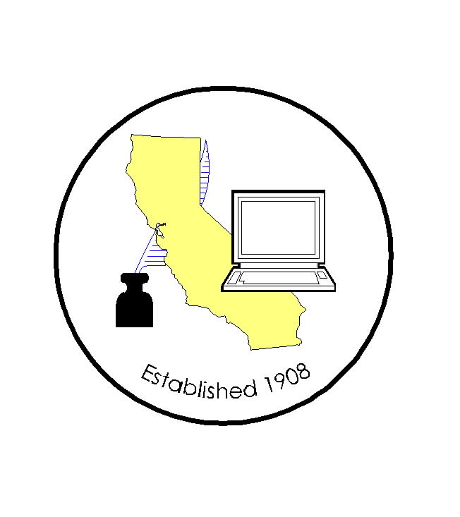
CALIFORNIA ASSOCIATION OF

CLERKS AND ELECTION OFFICIALS

January 8, 2010

TO: CACEO Members, Guests, Legislative Committee

FROM: Deborah Seiler and Jill LaVine, Co-Chairs

SUBJECT: CACEO LEGISLATIVE COMMITTEE MEETING

DATE: FRIDAY, January 15, 2010

TIME: 9:00 a.m. – 3:00 p.m.

LOCATION: County of San Diego Administration Building
1600 Pacific Highway 7th Floor
Tower 7 Conference Room
San Diego, CA 92101

From the airport, take a cab (about $10) or take the #992 city bus ($2.25 – exact change) to Ash Street. (The bus stop is right out side the Southwest terminal.)

Subcommittee Meetings, Thursday, January 14

1 pm – 3 pm Voters with Specific Needs – Tim McNamara

3pm – 5 pm HAVA/Certification/Voting Systems – Tim McNamara

AGENDA

9:00 am Welcome and Introductions

Approval of Minutes of December 9, 2009 meeting

Discussion of Bills
AB 1399
SB 6
Draft proposal by Paul Fong (attached)

Legislative Proposals
(Bring copies of your proposals to share with the group)
Noon Lunch (on your own)

1:00 pm Subcommittee Reports

